**Faculty of computers and information**

**Project Management’s Project**

**Supervision of:**

*Dr. Ibrahim Al-Awadi*

**Team members:**

*Noor Elden Mahmoud Mohammed*

*Eyad Mahmoud Ali*

*Heba Mostafa Ahmed*

*Naira Mohammed Hassan*

*Waad Ahmed Shaaban*

**Smart Parking**

***Smart Parking*??!**

A smart vehicle parking is a system that helps drivers to find a vacant spot using sensors in each parking space by detecting the presence or absence of a vehicle.

Automated Parking systems are generally powered by electric motors (that move vehicles into a storage position).

**Project Charter**

**Official project name**: Smart Parking System

**Project sponsor**: Ministry of Transportation.

**Project manager**: Noor Elden Mahmoud Mohammed.

**Project members:** Eyad, Heba, Waad, Naira.

**Purpose of the project**: Enhance the security. parks as many vehicles as possible with the least space possible. Solves the vandalism and pollution problems.

**Business case** with increase in the population, number of vehicles increases and due to unmanaged parking, it leads to many problems as increasing number of vehicles creates congestion, wastage of space, wastage of time, pollution, traffic problems and many other difficulties. The aim of this project is to create a prototype of a parking, Mobile application and a website known as Smart Parking System. This system will be used by any parking area. The system will help control the parking slot availability and also allow drivers to book for a parking slot before reaching the parking area. The reservation will be for a certain period of time of which if the driver does not reach the parking area, their reservation will be expired. The android application will help people book and see available parking slots. While the website, which can be accessed anywhere around will be used to see the available slot and also renew the reservation when they are expired.

**Project scope**

The App will allow drivers to book for a parking slot before reaching the parking area.

The system will help control the parking slot availability.

The website that allows users to book for a parking.

The App and Website allow users to be aware their parking status.

**Key deliverables**

Smart Parking mobile application that will work on both android and IOS.

Smart Parking Website. (QR-Code Card (used on parking area))

**Project milestones**

Requirements Review: Requirements specifications are complete, correct, approved and suitable. By 10/10/2021

Critical design review: Detailed designs fully implement the system architecture, are approved and are suitable for input into the development of code. By 15/11/2021

System test Review: The software product has passed system testing and is suitable for input into acceptance testing.by 15/11/2021

Product operational: The software is in use in its target operational environment.by 15/12/2021

**Project resources**

Staff: 2 android developers ,2 IOS developers, 1 full Stack Web-Developer

Hardware: 5 laptops, 2 servers

Software: Software licenses (Editors: Android-Studio, App Code, PHP Storm)

**Budget**:

budget allocated for project: 450000 L.E

**including** (servers, devices, developers and training).

**Constraints**

This project must be delivered within the specified budget

This project must be delivered on 1/1/2022

laptops or computers needed must be bought from (Apple & Microsoft companies)

**Assumptions (required event must be occur every fixed period)**

will get all resources required.

All-important stakeholders will come to the specified meetings.

All team members continue to the end of the project

**High level risks:**

1. Incorrectly planning.
2. hackers
3. Walk away from the target.
4. One of our employees leave the company
5. Choosing incorrect tools and technology
6. lost the trust of the clients

**Project Scope**

# **Project Scope Description:**

This project will mostly target the drivers and employees, but it will also be available to all people to facilitate their working life.

This project will start with local country then spreading worldwide.

# **Project Acceptance Criteria:**

1. Installation of the developed system at the actual location.
2. Creating the right remote control (application) to control devices easily.

# **Project Deliverables:**

# Application which is connected to the Smart Hub

1. Project plan, reports, documents and resources which return to the company.

# **Project Exclusions:**

One of customers’ requirements that the app must work without using internet, but the sponsor and manager refuse this request as it need a lot of time and cost.

# **Project Assumptions:**

1. Availability of all required resources.
2. The existence of the financier of the project and the availability of budget.
3. This application can run only on The IOS and Android operating system.

# **Project Constraints:**

* This project must be delivered within the specified budget.
* This project must be delivered on 1/1/2022
* Any laptops or computers needed must be bought from dell or apple companies.
* Rules of company and policies.

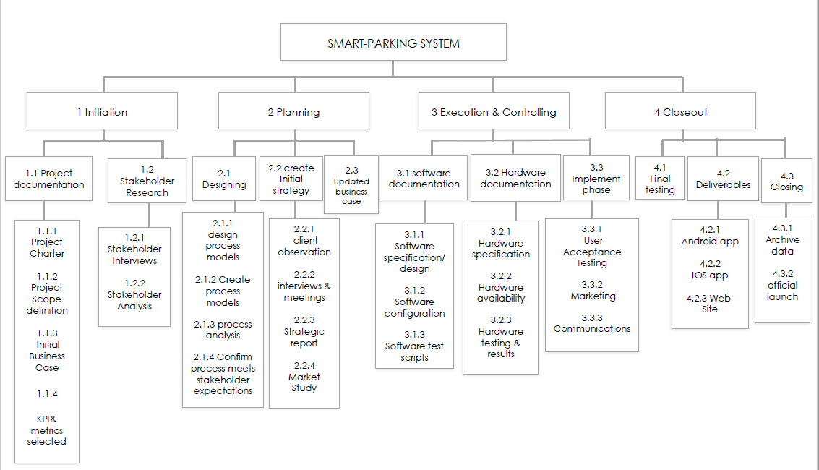**Work Breakdown Structure (WBS)**

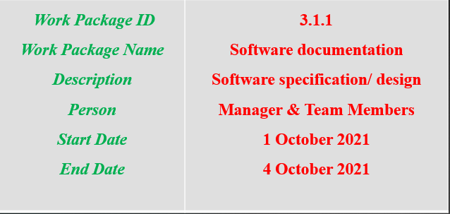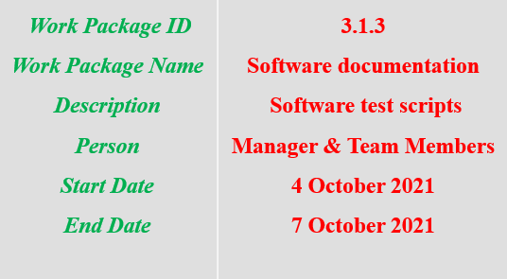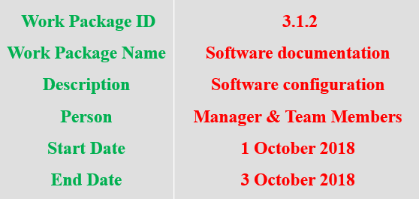**WBS DICTIONARY**

**Roles and Responsibilities Matrix**

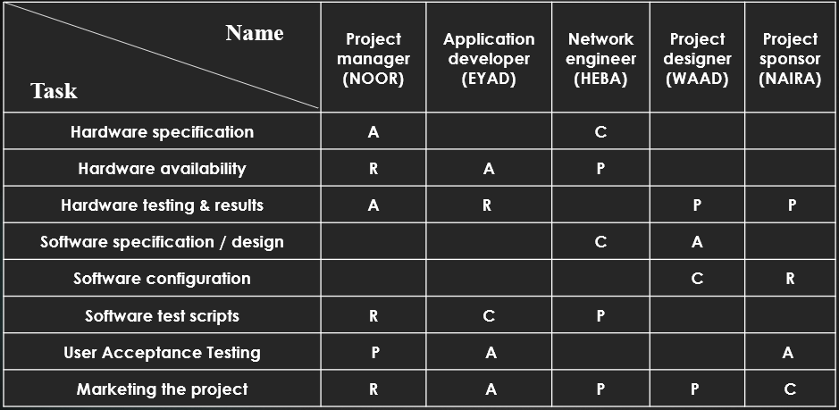

* **R-Reviews**
* **A-Approves**
* **P-Participant**
* **C-Creator**

**Project Network**

**Id description preceding activity Duration**

**A Hardware specification none 2**

**B Hardware availability none 2**

**C Hardware testing & results A 3**

**D Software specification / design C 4**

**E Software configuration C 3**

**F Software test scripts E, D 3**

**G User Acceptance Testing F 2**

**H Marketing G 3**

**Activity-on-Node Network**

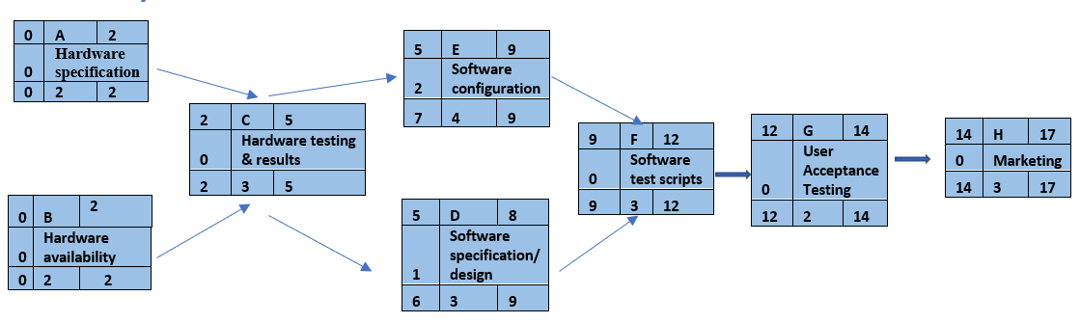

**The Critical Path (A, B) (C) (D) (F) (G) (H)**

**Resource constraints**

|  |  |  |  |  |  |  |  |  |  |  |  |  |  |  |  |  |  |  |  |  |  |  |  |  |  |  |  |  |  |  |  |
| --- | --- | --- | --- | --- | --- | --- | --- | --- | --- | --- | --- | --- | --- | --- | --- | --- | --- | --- | --- | --- | --- | --- | --- | --- | --- | --- | --- | --- | --- | --- | --- |
| **ID** | **RES** | **DUR** | **ES** | **LF** | **SL** | **0** | | **1** | | **2** | | **3** | | **4** | | **5** | | **6** | | **7** | | **8** | | **9** | **10** | **11** | **12** | **13** | **14** | **15** | **16** |
| **Hardware specification** | **2** | **2** | **0** | **15** | **5** | **2** | | **2** | |  | |  | |  | |  | |  | |  | |  | |  |  |  |  |  |  |  |  |
| **Hardware availability** | **3** | **2** | **0** | **15** | **0** | **3** | | **3** | |  | |  | |  | |  | |  | |  | |  | |  |  |  |  |  |  |  |  |
| **Hardware testing & results** | **4** | **3** | **15** | **22** | **0** |  | |  | | **4** | | **4** | | **4** | |  | |  | |  | |  | |  |  |  |  |  |  |  |  |
| **Software specification / design** | **2** | **4** | **22** | **32** | **0** |  | |  | |  | |  | |  | | **2** | | **2** | | **2** | | **2** | |  |  |  |  |  |  |  |  |
| **Software configuration** | **2** | **3** | **22** | **32** | **2** |  | |  | |  | |  | |  | | **2** | | **2** | | **2** | |  | |  |  |  |  |  |  |  |  |
| **Software test scripts** | **3** | **3** | **32** | **37** | **0** |  | |  | |  | |  | |  | |  | |  | |  | |  | | **3** | **3** | **3** |  |  |  |  |  |
| **User Acceptance Testing** | **3** | **2** | **37** | **45** | **0** |  | |  | |  | |  | |  | |  | |  | |  | |  | |  |  |  | **3** | **3** |  |  |  |
| **Marketing** | **5** | **3** | **45** | **55** | **0** |  | |  | |  | |  | |  | |  | |  | |  | |  | |  |  |  |  |  | **5** | **5** | **5** |
| **Total Resource Load** | | | | | | | **5** | | **5** | | **4** | | **4** | | **4** | | **4** | | **4** | | **4** | | **2** | **3** | **3** | **3** | **3** | **3** | **5** | **5** | **5** |
| **Resource Available** | | | | | | | **5** | | **5** | | **5** | | **5** | | **5** | | **5** | | **5** | | **5** | | **5** | **5** | **5** | **5** | **5** | **5** | **5** | **5** | **5** |

|  |  |  |  |  |  |  |  |  |  |  |  |  |  |  |  |  |  |  |  |  |
| --- | --- | --- | --- | --- | --- | --- | --- | --- | --- | --- | --- | --- | --- | --- | --- | --- | --- | --- | --- | --- |
| **Id** | **DUR** | **Task** | **Budget** | **0** | **1** | **2** | **3** | **4** | **5** | **6** | **7** | **8** | **9** | **10** | **11** | **12** | **13** | **14** | **15** | **16** |
| **A** | **2** | **Hardware specification** | **100** | **50** | **50** |  |  |  |  |  |  |  |  |  |  |  |  |  |  |  |
| **B** | **2** | **Hardware availability** | **20** | **10** | **10** |  |  |  |  |  |  |  |  |  |  |  |  |  |  |  |
| **C** | **3** | **Hardware testing & results** | **15** |  |  | **5** | **5** | **5** |  |  |  |  |  |  |  |  |  |  |  |  |
| **D** | **4** | **Software specification / design** | **80** |  |  |  |  |  | **20** | **20** | **20** | **20** |  |  |  |  |  |  |  |  |
| **E** | **3** | **Software configuration** | **45** |  |  |  |  |  | **15** | **15** | **15** |  |  |  |  |  |  |  |  |  |
| **F** | **3** | **Software test scripts** | **15** |  |  |  |  |  |  |  |  |  | **5** | **5** | **5** |  |  |  |  |  |
| **G** | **2** | **User Acceptance Testing** | **20** |  |  |  |  |  |  |  |  |  |  |  |  | **10** | **10** |  |  |  |
| **H** | **3** | **Marketing** | **60** |  |  |  |  |  |  |  |  |  |  |  |  |  |  | **20** | **20** | **20** |
| **Total** | | | **355** | **60** | **60** | **5** | **5** | **5** | **35** | **35** | **35** | **20** | **5** | **5** | **5** | **10** | **10** | **20** | **20** | **20** |
| **Commutative** | | | | **60** | **120** | **125** | **130** | **135** | **170** | **205** | **240** | **260** | **265** | **270** | **275** | **285** | **295** | **315** | **335** | **355** |

**Budget Baseline:**

**Risk Management & Monitoring**

* + 1. **Incorrectly planning**

We can solve this following four steps:

* 1. Review problem statements.
  2. List possible solutions for each real cause of the problem.
  3. Weigh the good side and bad side of each possible solution.
  4. Select the best solution

1. **Hackers**

We can stand against hackers’ attacks by building a strong security system.

1. **Increase in the cost**

Sometimes cost of the manufacturing the product may raise in a way that van lead to large losses. We can solve this by looking for a cheaper resources with the same efficiency or raising the price of the product without a big void from competing products.

1. **One of our employees leave the company**
2. Ask him for the reason he left for and try to fix it.
3. Search quickly for a high-quality employee to take his place.
4. **Choosing incorrect tools and technology**

You need to look for someone who can help you identify the IT infrastructure you need that will support your business today and can help you plan for the future at the same time.

**6. lost the trust of the clients**

We can solve this by:

### Determine the source of the problem.

### Doubling down on the quality of your customer service

### Give your customers an offer they can’t refuse

### Offering an additional incentive.